Tutorial : Create a Serverless Workflow

1. Create a State Machine and Serverless Workflow

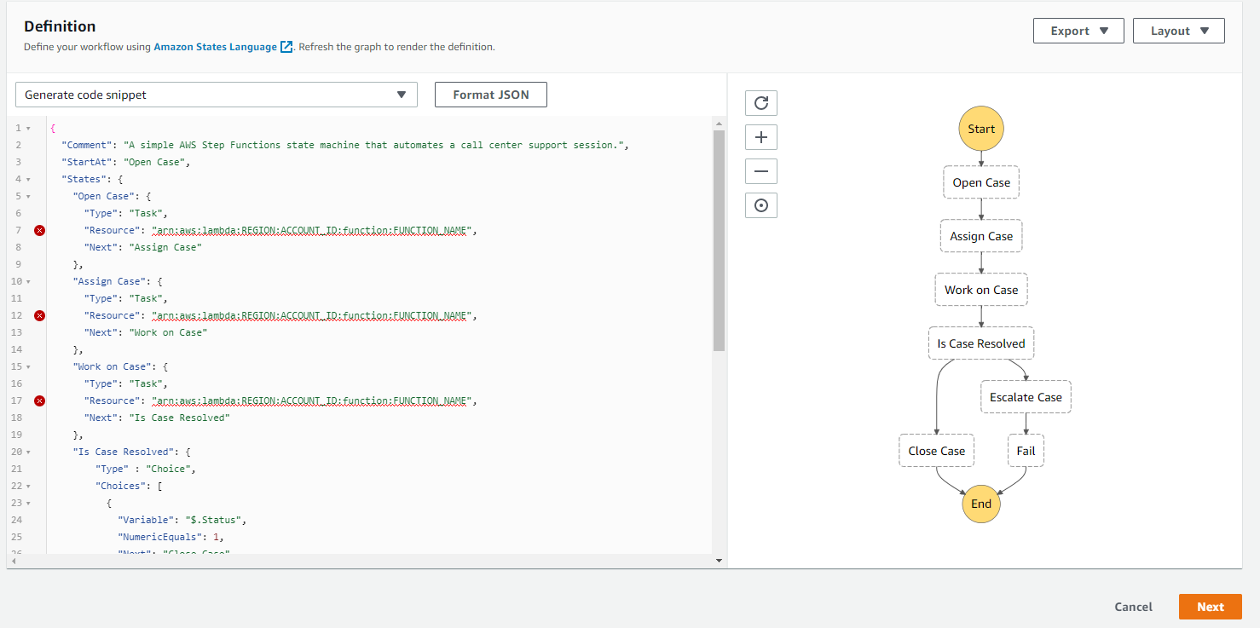

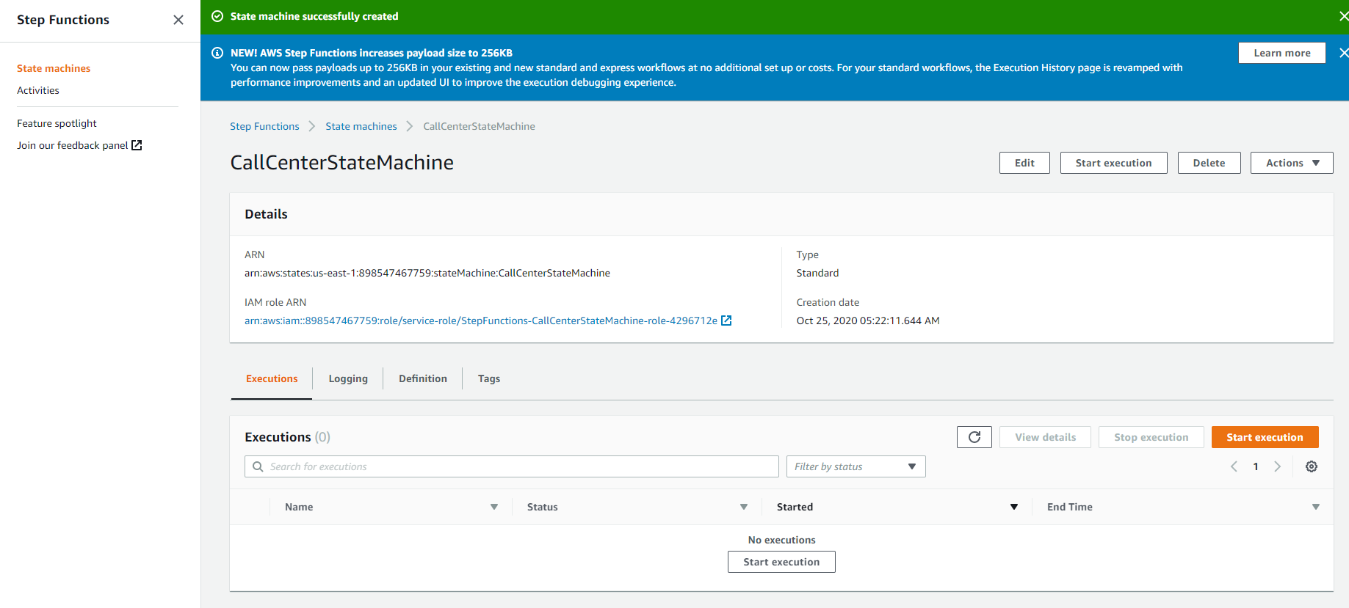

1. Create an AWS Identity and Access Management (IAM) Role

Copy Role ARN

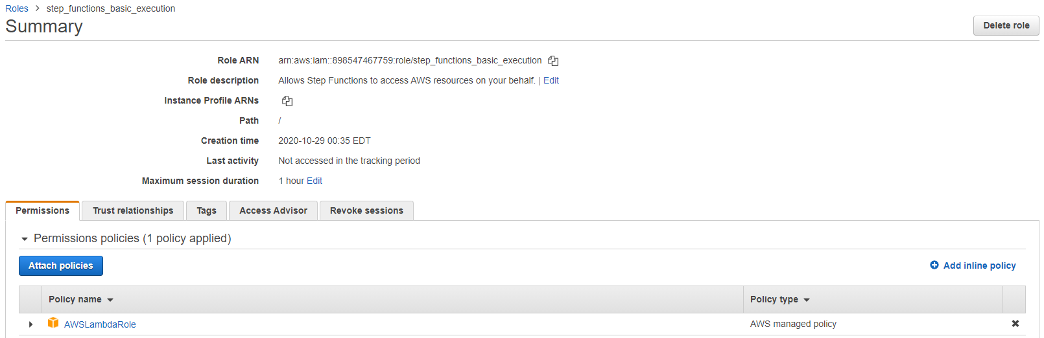

1. Add ARN Role to State Machine

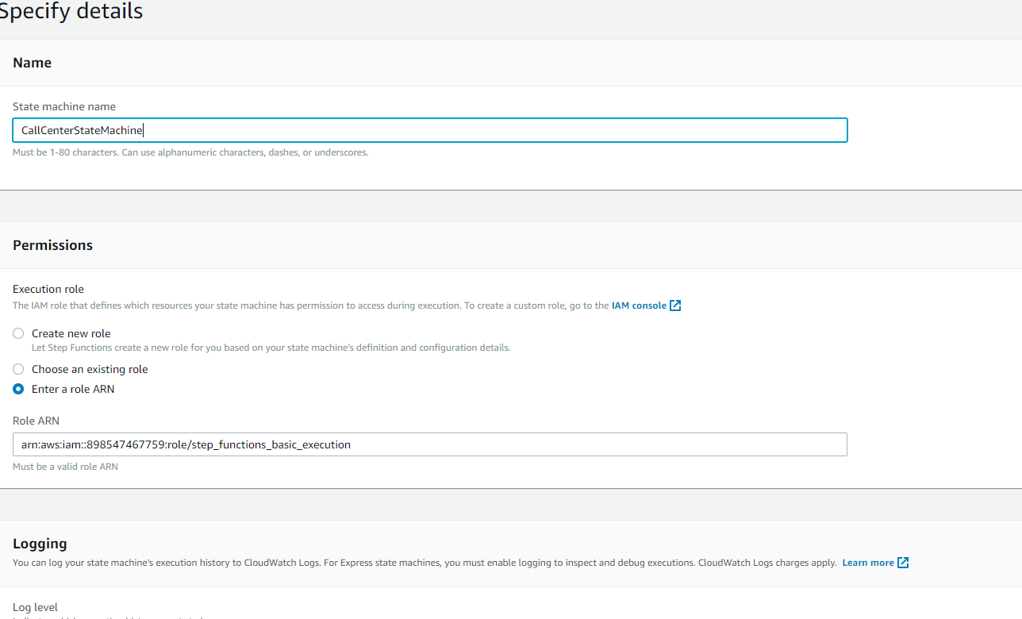

1. Create your AWS Lambda Functions

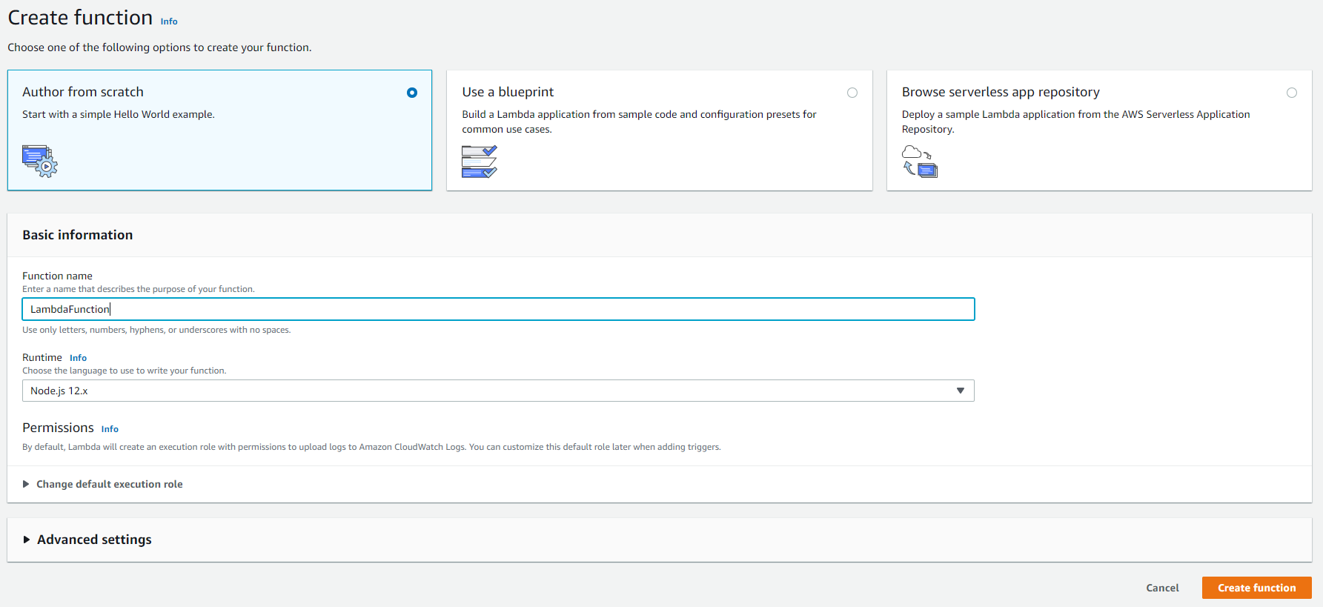

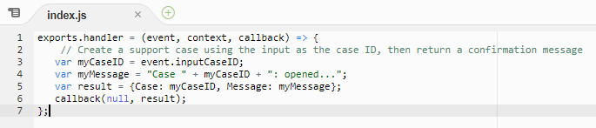

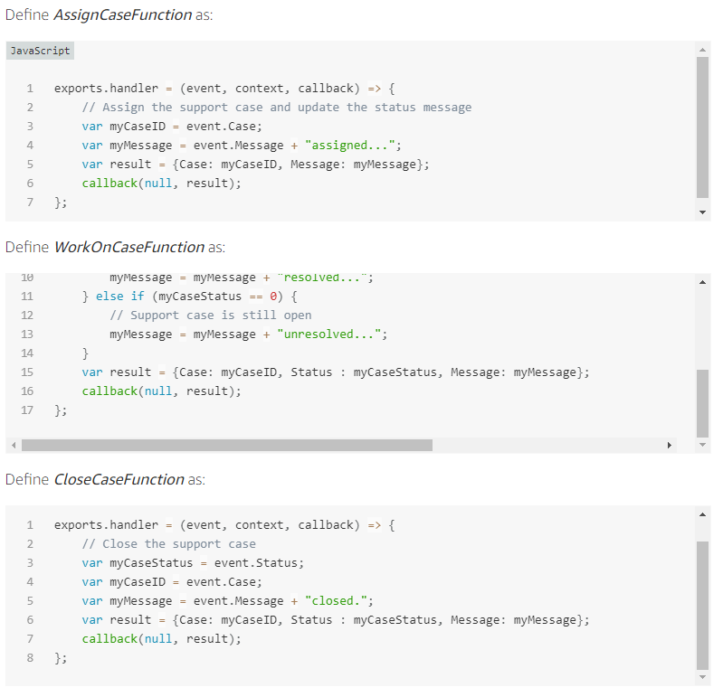

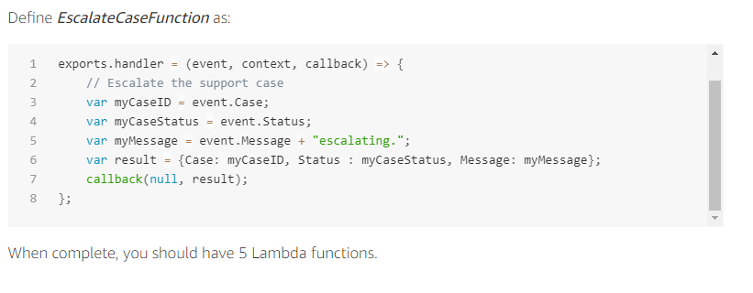

Copy the ARNs of the function and paste in respective resource

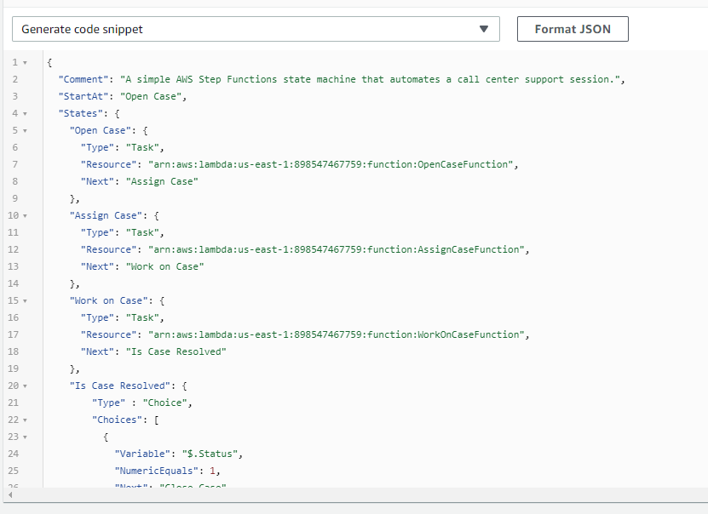

1. Execute Your Workflow

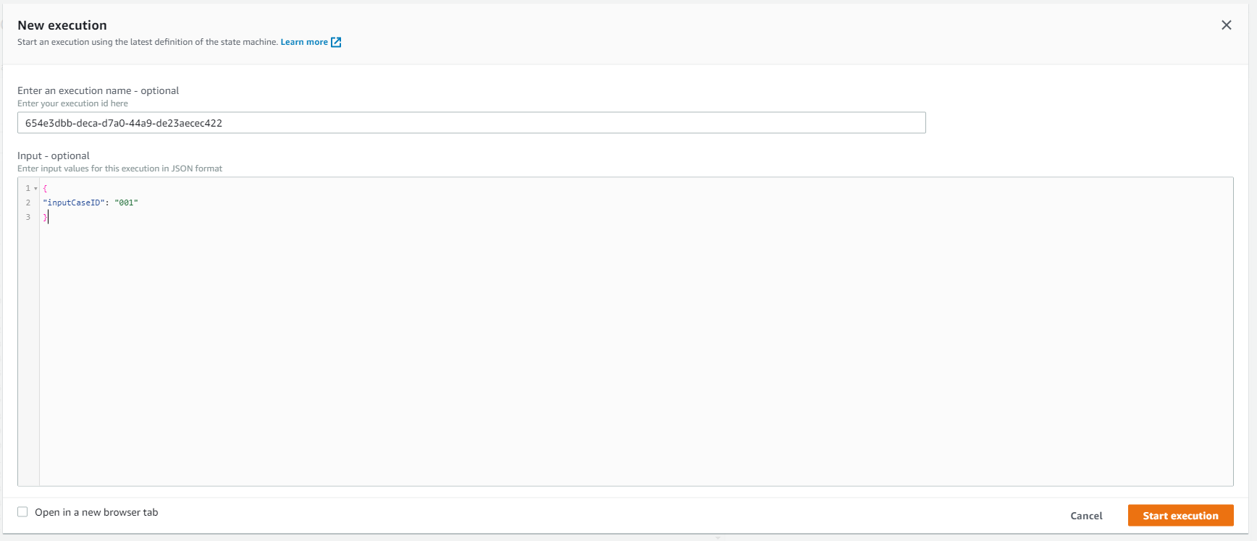

View Graph after Execution and check step input, output

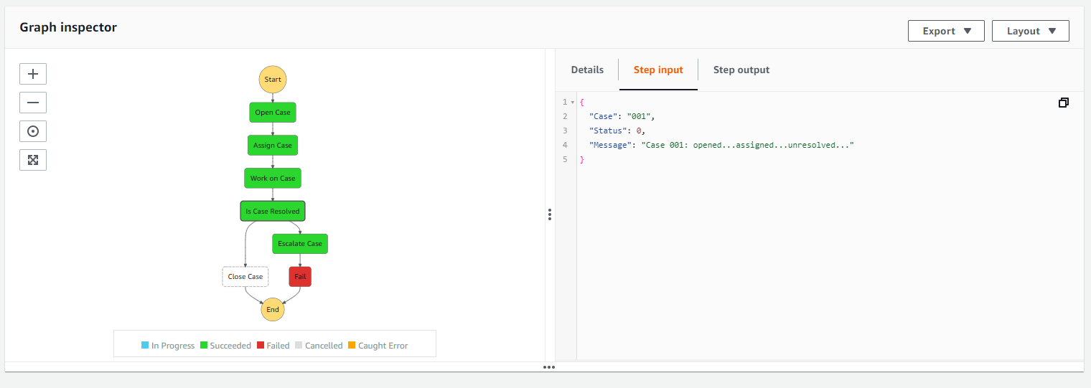

1. Terminate your Resources

Delete State Machine

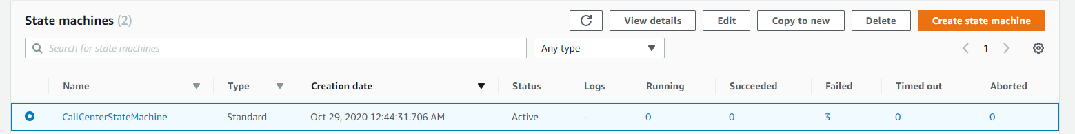

Delete Lambda Functions

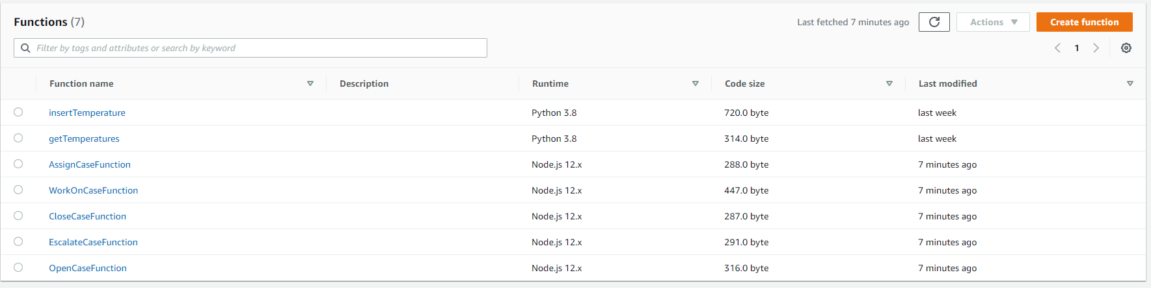

Delete Role

